Chuck Cohen: why do the nations rage?

Chuck Cohen is a messianic Jew who has lived with his family in Jerusalem since 1989. He is a published author, international speaker and teacher, and a director of Intercessors for Israel. A DVD recording of his visit to Inverness along with a personal interview is now available.

Why do the nations rage, and the peoples meditate a vain thing?
Psalm 2:1
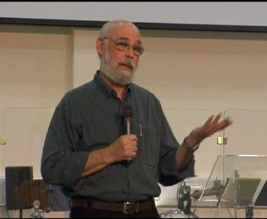
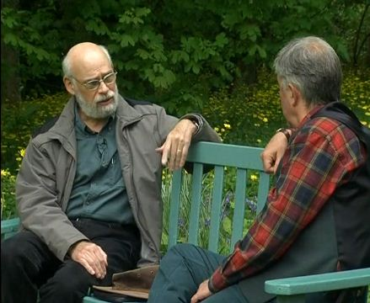
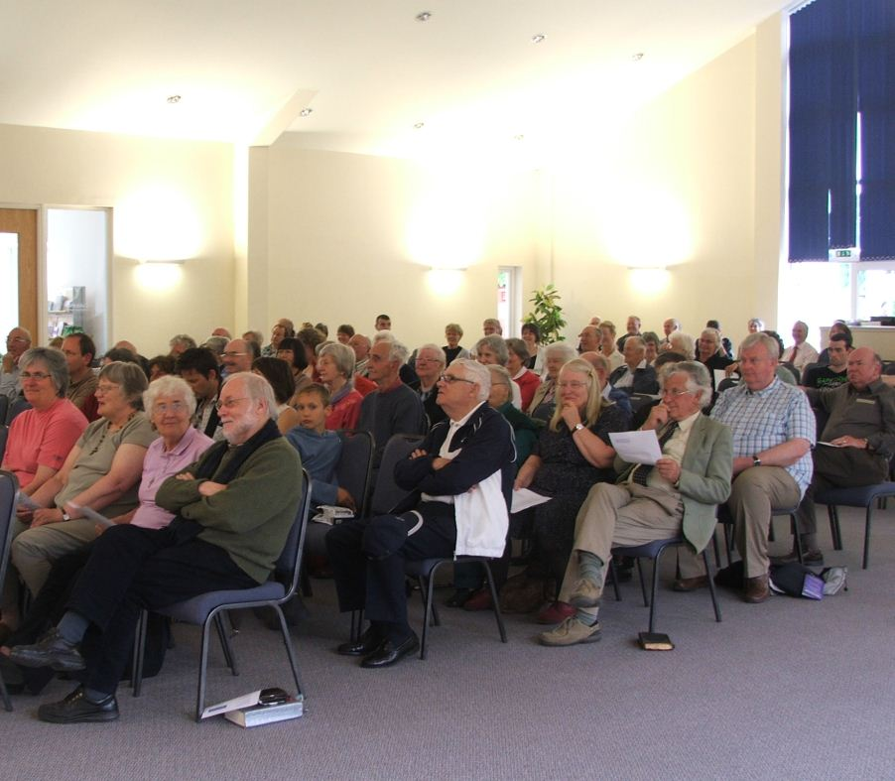
In June for the past 7 years Chuck Cohen has co-led an Intercessors for Israel Prayer Week at Ellel Scotland's Blairmore House near Huntly.
This year he spoke to a meeting in Inverness in the week following the controversy surrounding the boarding by Israeli military personnel of a ship bound for Gaza.
The meeting was sponsored by Yachad – a Scottish grouping of individuals and ministries which has a prayerful concern regarding God's purposes for the Jewish people and the nation of Israel.
The following week, Chuck also gave a personal interview to Christians Together during his time at Blairmore House.
He brings solid biblical teaching to bear on the subject of current affairs, including the situation in Israel alongside God's word.
A DVD is now available of Chuck speaking at the Inverness meeting in Inverness and includes the 30-minute interview in the course of the week of prayer.
In the course of the Inverness address Chuck speaks about God's way of salvation in Jesus Christ and His past and present purposes for the Jewish people.
In the subsequent interview he gives his testimony of how he came to know Yeshua HaMashiach as His saviour, and addresses the very important issue of Replacement Theology which teaches that the church has replaced Israel in all of God's end time purposes. The discussion also covers current issues relating to the troubles in the Middle East.
DVD Trailer

Have a look at a short trailer with clips from the Inverness meeting and short extracts from the interview. The full DVD includes the Question and Answer session at the Inverness meeting.
The DVD (including complimentary CD) costs £10 plus £2.50 postage

Total price £12.50 each (orders above £50 post free).
On-line orders for copies of the DVD should be placed with Thistle Channel TV.

TO ORDER BY MAIL
Please print out this page, enter details and post your order to the address at foot of page.

CHUCK COHEN (Inverness / Blairmore) DVD

Please supply .............. (no. of copies) of Chuck Cohen DVD.

Cost: £10 per DVD plus £2.50 pp. (Total: £12.50 per copy; orders over £50 post free).
Cheques made payable to: Thistle Channel
Please supply the above to (enter your address below) -
Title/Name (PLEASE PRINT)................................................................................

Address .....................................................................................

...................................................................................................

....................................................................................................

............................................................. Post Code .....................

E-mail address (optional).................................................................@....................................................

Post this completed order form to: Thistle Channel, 35 Spires Close, Nairn IV12 5PZ

Thank you for your order and trust that you enjoy the DVD

