FRIENDS OF INVERNESS YMCA/CYC

NEWSLETTER – SEPTEMBER 2009

“For He loves us with unfailing love; the Lord’s faithfulness endures for ever. Praise the Lord!” (Psalm 117:2 (NLT)
Prayer topics from the Board of Management

The arrangements for the 150th celebration scheduled for 20th November - that it would be a night of testimony and rejoicing in God’s faithfulness

For two new young Board members, Ross Nicol and Edward Kelsey - that they will make a positive contribution to the ongoing work

For provision for our present needs and future plans as we submit applications for grants, but more importantly as we develop plans to appeal for support from the Christian community so that our work will be completely funded by believers and not restricted in any way by grants with strings attached

For blessing upon Tom and Joyce Coyle as they run the café in the CYC and for more support from Christians for this venture – come and have a coffee there!

Prayer topics from the Youth Worker

Neil Prentice, Katie Mackintosh and Alison Carey as they settle in to university and working life

Ruth Macdonald and Scot Fraser as they take on full time placement in the CYC with Project Scotland

Arrangements for the concert on Saturday, 31ST of October in the Culduthel Christian Centre to launch the Soul Bearing album featuring Tommie MacKay. Watch out for advertising of time, tickets, etc.

Resumption of the youth outreach programme after the summer break, especially that the new young people settle in quickly

Give thanks for the outreach with Luis Palau and the boost which it has given to the work with young people

Prayer topics from the Friends

Give thanks for the exceptional sum of £1,400 raised at the coffee morning on 7th March to meet the costs of re-covering the pool table.
Pray for a good attendance and financial support at our Spring Sale on 16th May
Pray for good weather and a positive response to the sponsored walk on 23rd May
Pray for the committee as it plans further events and give thanks for two new members – Esther Dowey and Archie Fraser.

Prayer topics from the Friends

Give thanks for funds of £450.60 raised at the Spring Sale for the Luis Palau festival

Pray for good support for our annual Autumn Sale taking place on Saturday, 7th November. New crockery has been bought for the upstairs kitchen to give a more modern feel to these events.

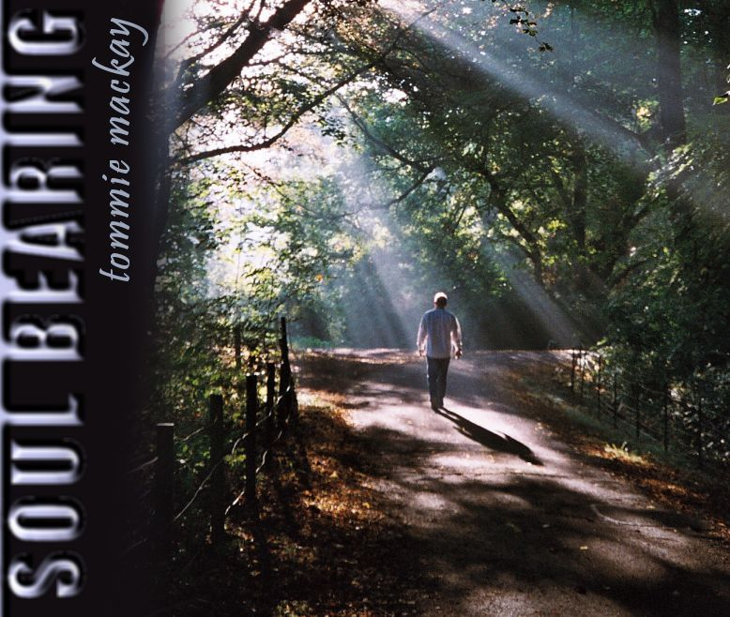

A date for your diary

150th anniversary Celebration Concert

and
launch of Tommie Mackay’s
new album

SOUL BEARING

Saturday, 31st October

31st October 2009

This Newsletter is issued by the Friends of the YMCA/CYC. If your details have changed or you no longer wish to receive the Newsletter, please contact Anne Muirden, Secretary of the Friends, either by phone (01463 239412), e-mail ac.muirden@btinternet.com or writing to 3 Dornie Place, Inverness, IV2 4BX.

